**TailWind CSS**

Muhammad Wasi Ul haq

[Company name]  [Company address]

**Background Classes and Shades:**

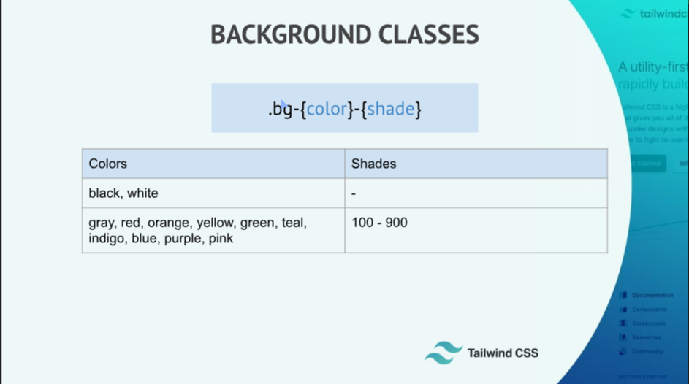

**Sample Code:**

<html>

<head>

<link href="https://unpkg.com/tailwindcss@^1.0/dist/tailwind.min.css" rel="stylesheet">

</head>

<body class="">

<div class="bg-gray-200">Text</div>

<div class="bg-white">Body</div>

<div class="bg-blue-800">Footer</div>

</body>

</html>

**Element Sizing and TailWinds’s Number System:**

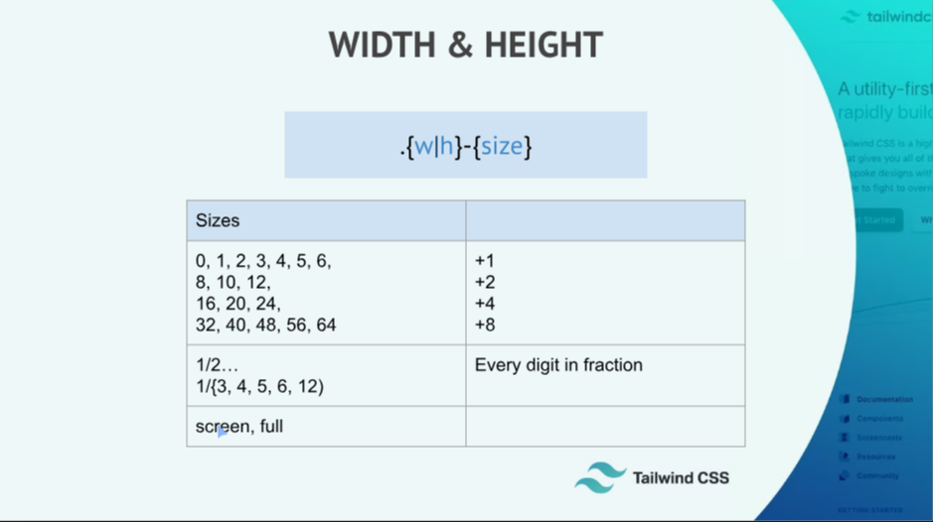

**Sample Code:**

<html>

<head>

<link href="https://unpkg.com/tailwindcss@^1.0/dist/tailwind.min.css" rel="stylesheet">

</head>

<body class="">

<div class="bg-gray-500 w-32 h-32">Text</div>

<div class="bg-gray-800 w-3/12">Text</div>

<div class="bg-red-800 w-3/12">Text</div>

<div class="bg-orange-800 w-6/12">Text</div>

</body>

</html>

**Padding and Margin:**

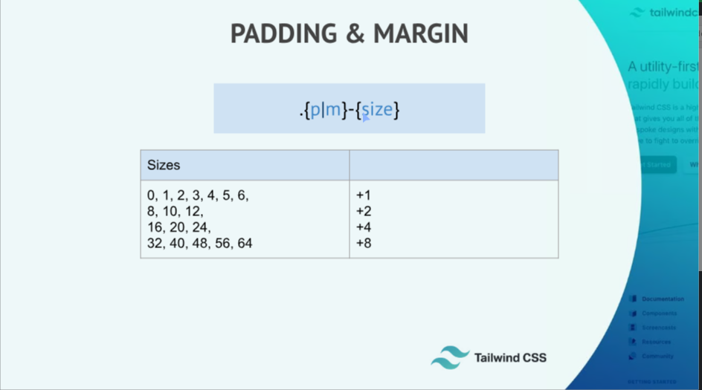

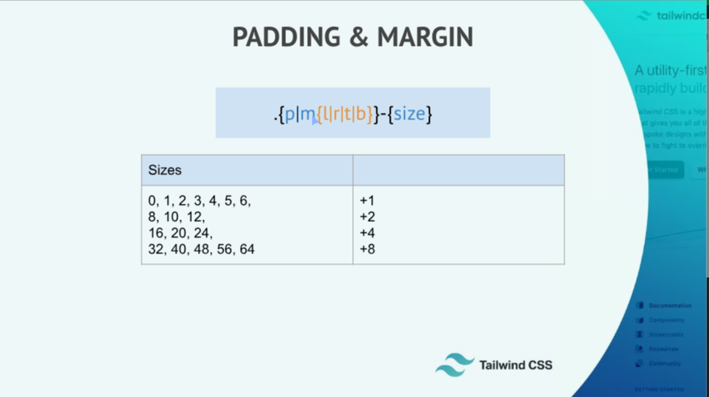

**Text Styling Part-1:**

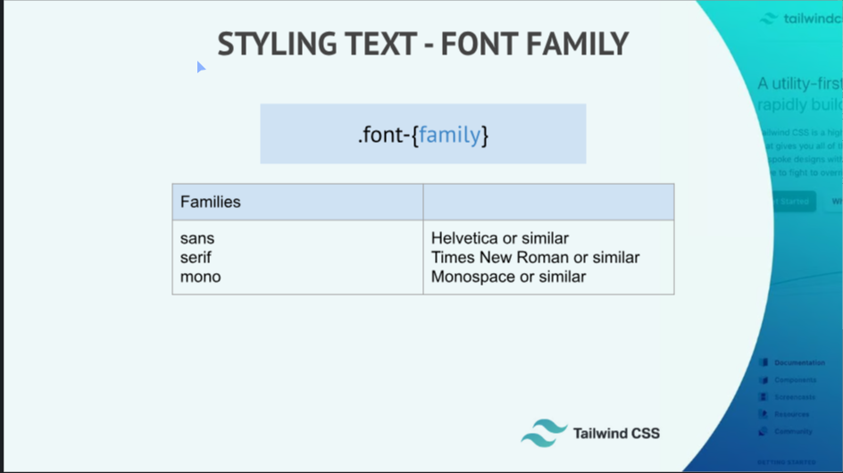

**Styling Text Part 02:**

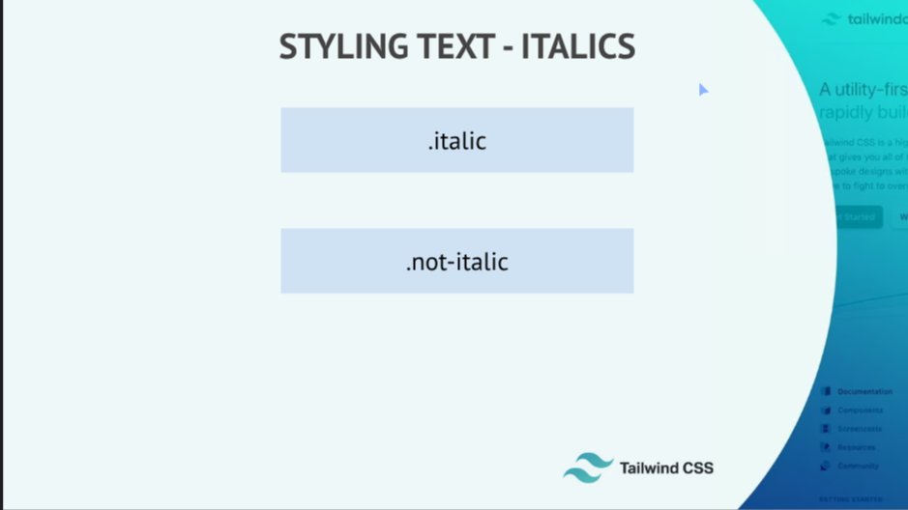

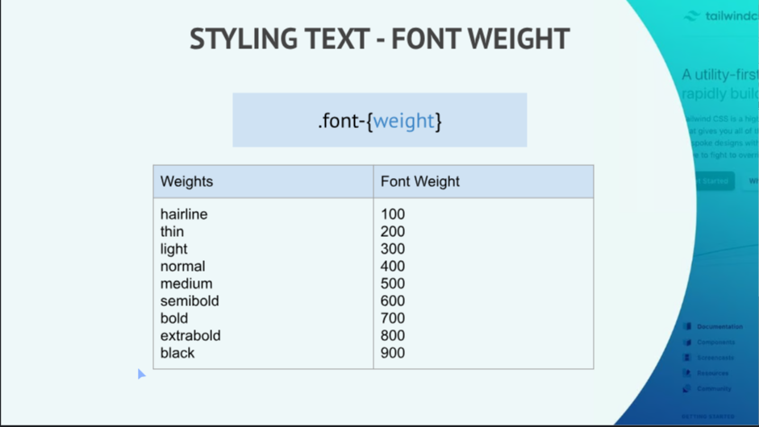

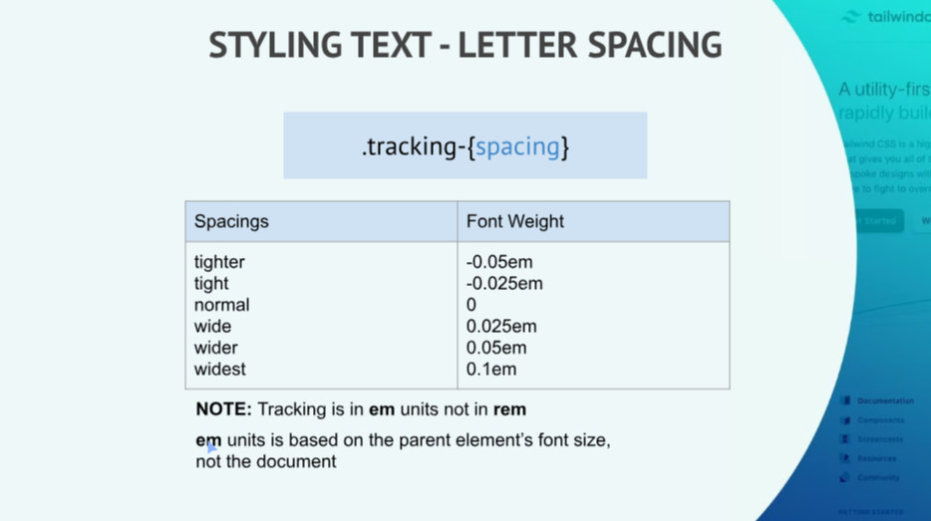

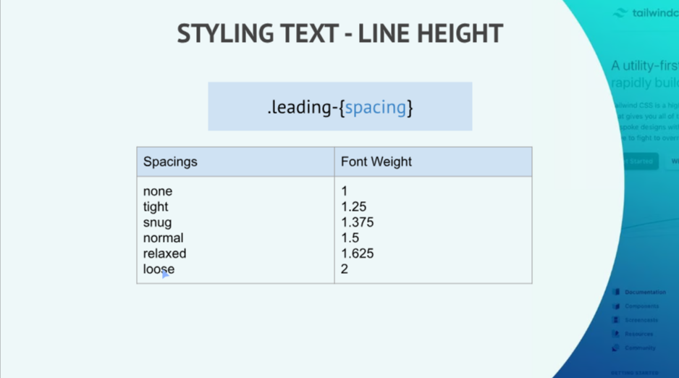

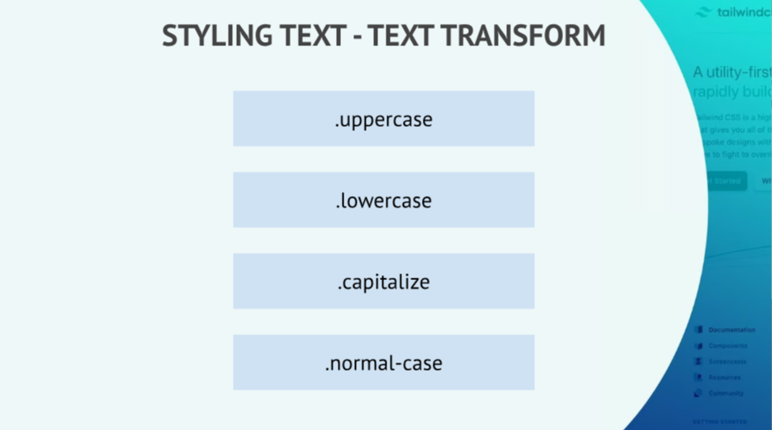

**Boder Stylings:**

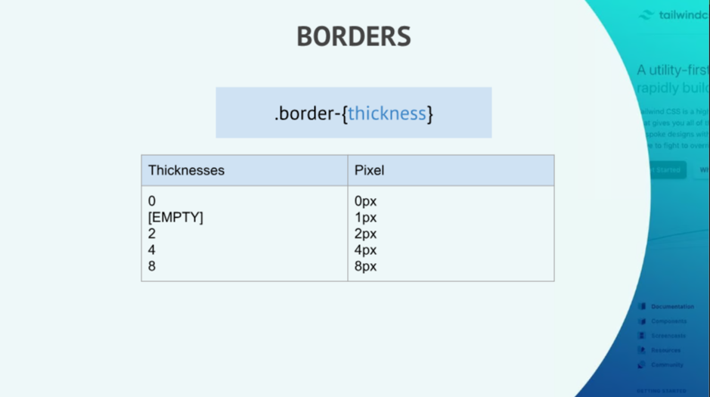

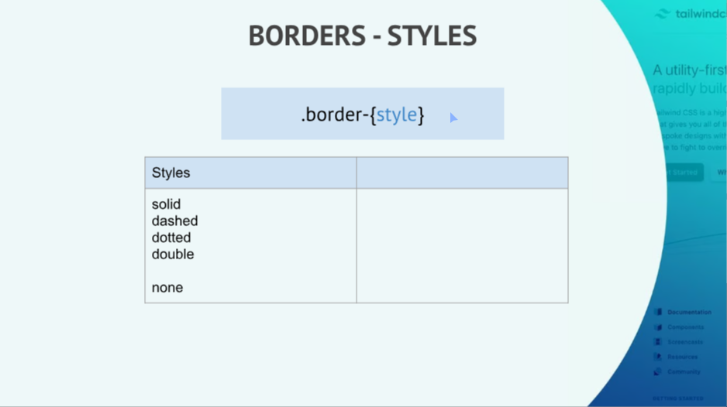

**Display Modes:**

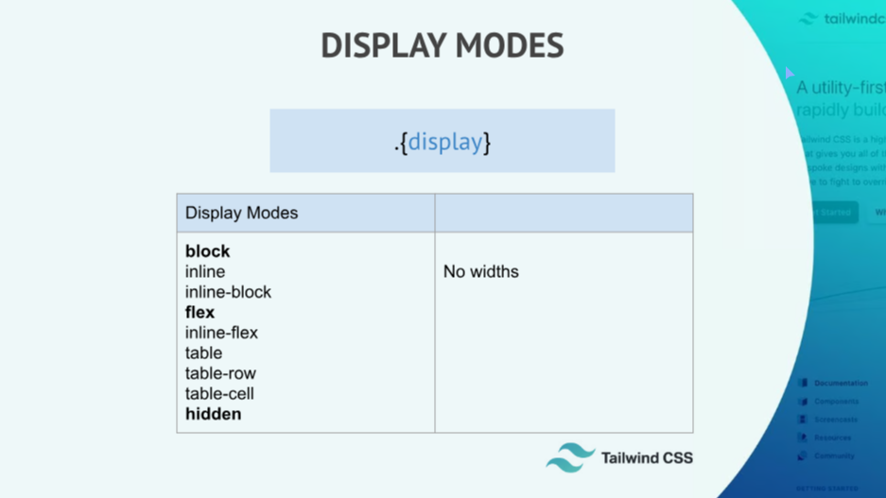

**FlexBox:**

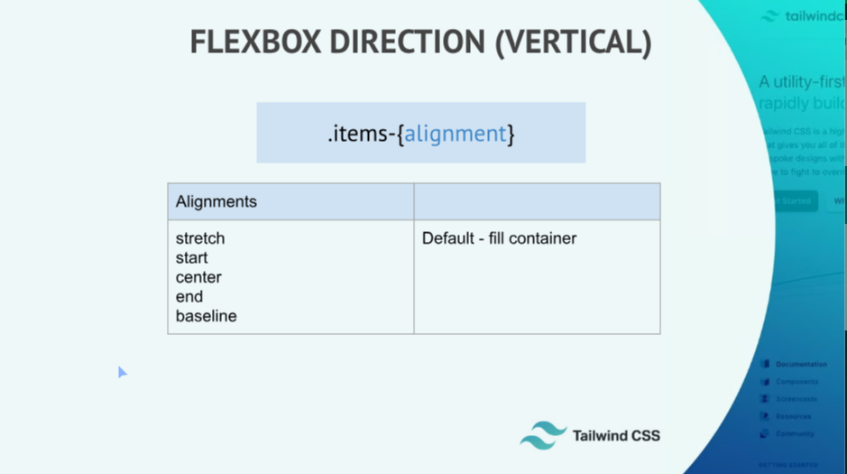

<html>

<head>

<link href="https://unpkg.com/tailwindcss@^1.0/dist/tailwind.min.css" rel="stylesheet">

</head>

<body>

<!-- Example 1 -->

<div class="h-screen flex justify-around items-center">

<div class="bg-yellow-600 w-16 h-16">1</div>

<div class="bg-teal-700 w-16 h-16">2</div>

<div class="bg-red-700 w-16 h-16">3</div>

</div>

<!-- Example 2 -->

<!-- <div class="flex">

<div class="text-2xl">&bull;</div>

<p class="text-5xl ">Hello there.</p>

</div> -->

</body>

</html>

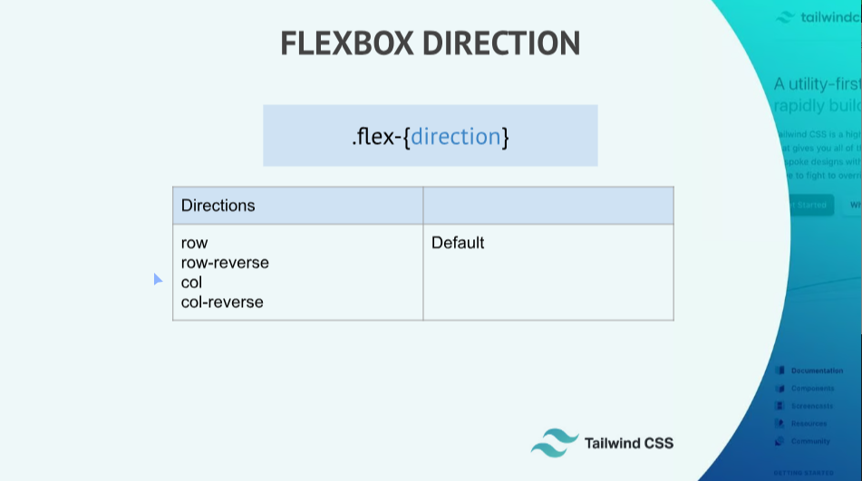

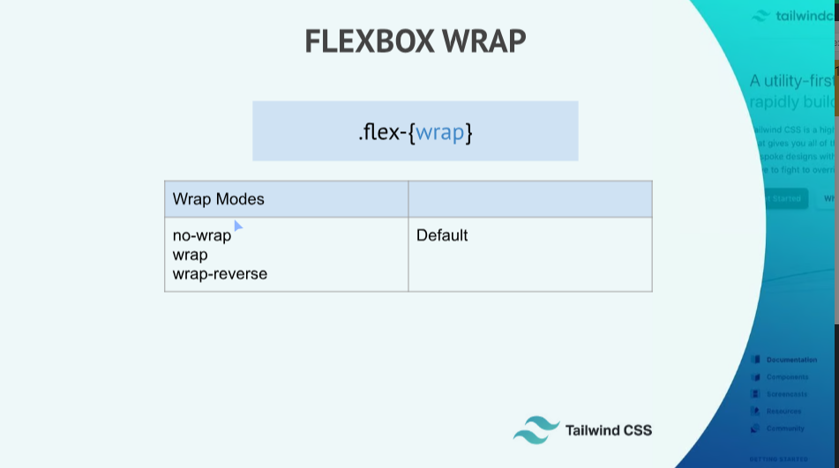

**Responsive Design:**

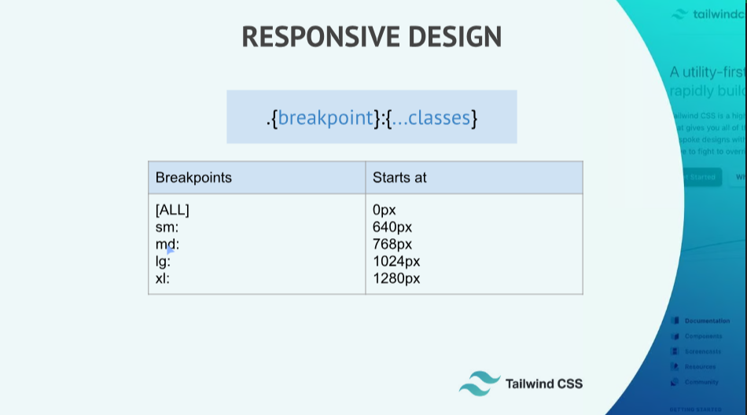

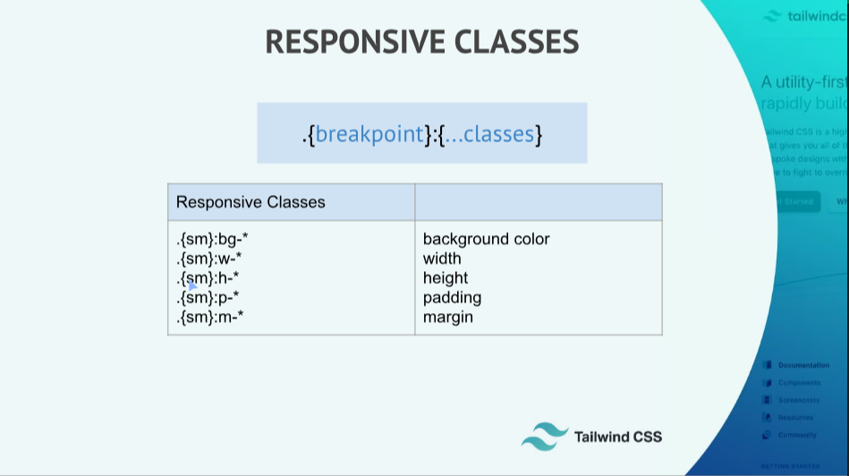

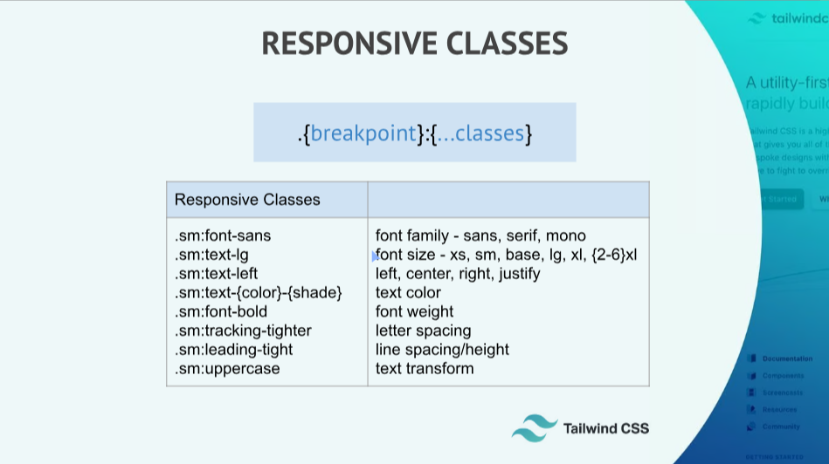

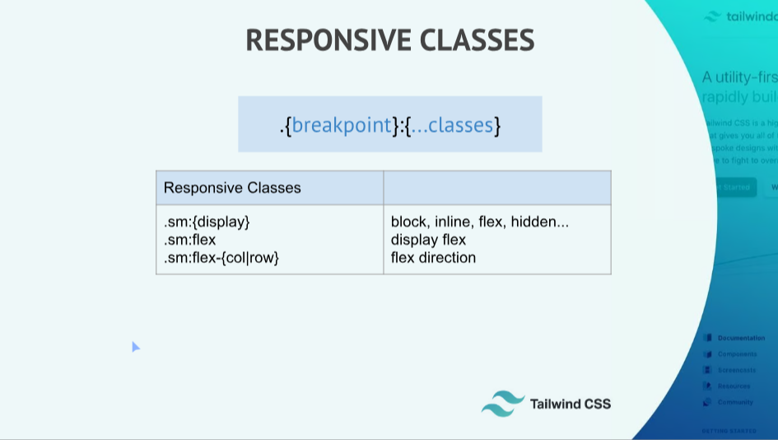

**Hover Modifier:**

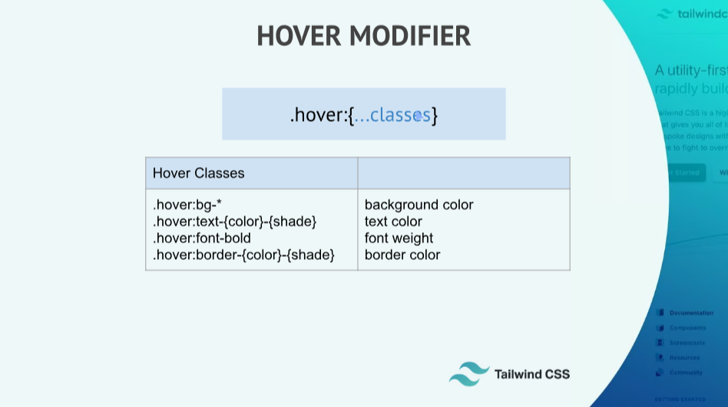

**Focus Modifiers:**

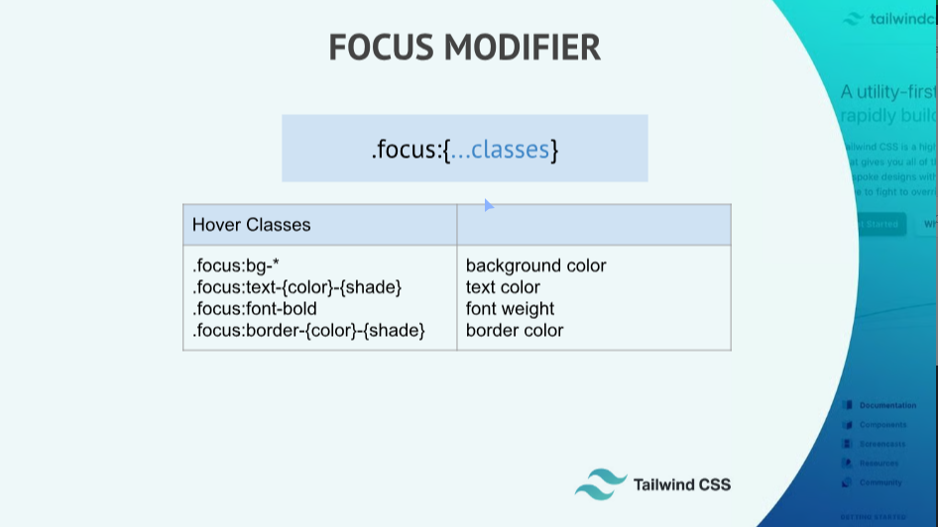

**Combination modifiers:**

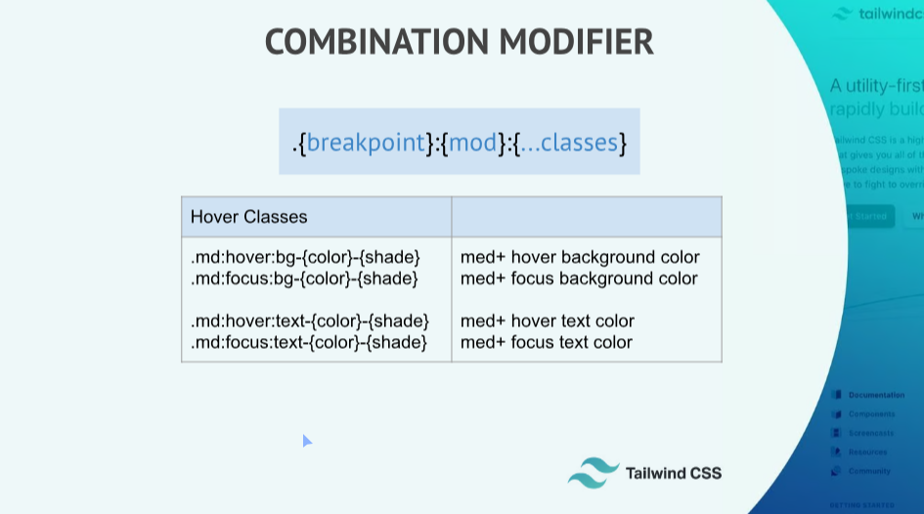

**Other Utilities:**



